|  |  |
| --- | --- |
| **Assignment / Project] – External Document** |  |
| <Course Code>  <Couse Name> |
| [Odd / Even / Compact] Semester Year 9999/9999 |

* Project Title

HE-Fish

* Introduction

HE-fish is a mobile app that allows users to log in and register using either their email or Google account. The app also allows users to perform CRUD (Create, Read, Update, Delete) operations on fish data. The team working on the project includes Calvin and Alfrid who are working on the Flutter-Dart side (Front-end) and Jonathan who is working on the Express.js (Back-end).

Software requirements for the project:

* Android SDK API 27
* Flutter SDK 3.0.2
* XAMPP 8.0.7
* Node JS 14.17.1
* Android Studio 2021.2.1 Patch 1 (Optional, can be replaced by VSCode & other emu)
* Visual Studio Code

How to run the project in debug mode:

* Run XAMPP and activate Apache, MySQL. Then import the database called “he-fish” to the database.
* Open both front-end and back-end project files in VSCode. To start the backend server type “npm start” in the console. To run the flutter, make sure that you have your debugging device connected via USB Debugging or emulator running (Google sign-in feature doesn’t work in emulator due to Google’s dependency). Before running, navigate to “lib > class > host.dart” and change the localhost to your needs based on the tutorial written on the file. Then type “flutter pub get” then “flutter run” in the console.
* Graphical user interface, application

  Description automatically generatedA picture containing text, tool, screenshot

  Description automatically generatedReport / Documentation

Figure 2 Register page

Figure 1 Splash screen

Figure 4 Login with google

Figure 3 Login page

Figure 6 Home page

Figure 5 Insert fish page

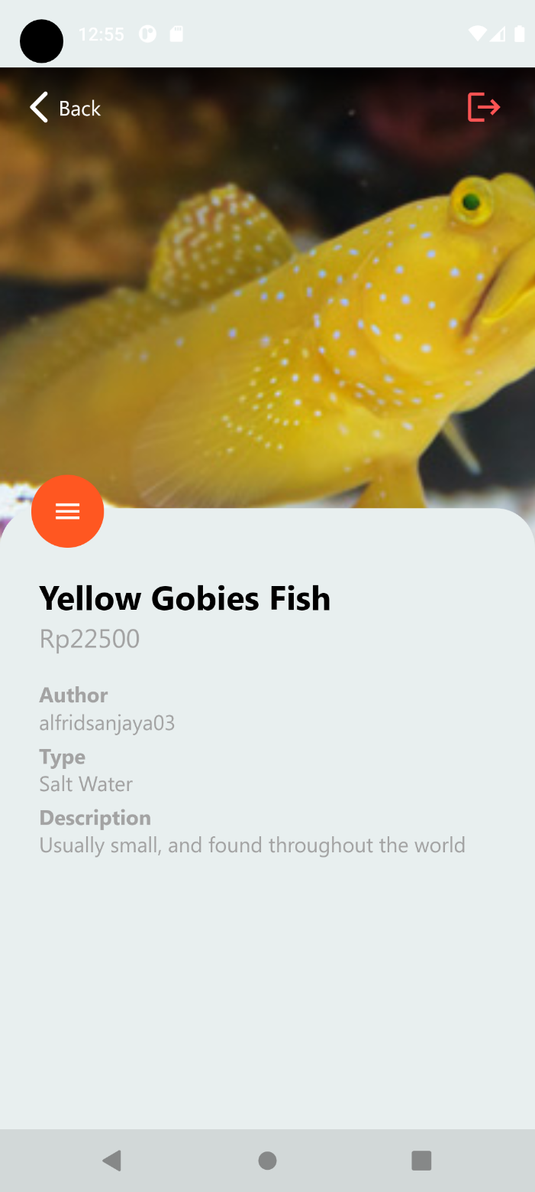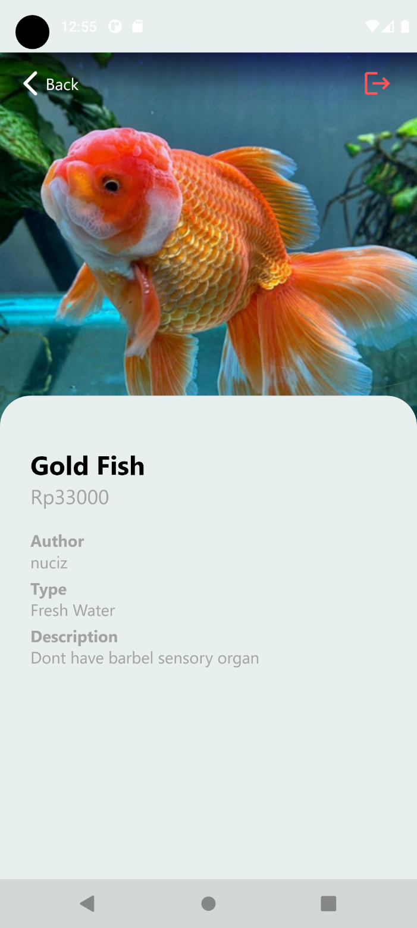

Figure 8 Fish detail page (Author view)

Figure 7 Fish detail page

Figure 10 Filtered fish list page

Figure 9 Fish detail page (Author view w/ option)

Figure 12 Edit fish page

Figure 11 Empty fish list page

Figure 14 HEFish in the app list

Figure 13 All fish list page

Figure 15 HEFish logo

* Reference
* https://www.liveaquaria.com/images/categories/thumbs/th_67194_Emperor_Angelfisha.jpg
* https://www.liveaquaria.com/images/categories/thumbs/th_109217_Lightning_Maroon_Clownfish.jpg
* <https://www.liveaquaria.com/images/categories/thumbs/th102072YashaGoby.jpg>
* <https://www.liveaquaria.com/images/categories/thumbs/th80329MilesLionfish.jpg>
* <https://www.liveaquaria.com/images/categories/thumbs/th91807SammaraSquirrelfish.jpg>
* <https://www.liveaquaria.com/images/categories/thumbs/th_89800_Oranda_Goldfish_Asst.jpg>
* <https://www.liveaquaria.com/images/categories/thumbs/th89842HiFinLyretailSwordtail.jpg>
* <https://www.liveaquaria.com/images/categories/thumbs/th_89824_Red_Fire_Guppy.jpg>
* <https://www.liveaquaria.com/images/categories/thumbs/th-cat-832-Bettas.jpg>
* <https://www.liveaquaria.com/images/categories/thumbs/th_39880_Walkers_Panchax_Killifish_Single.jpg>
* https://www.liveaquaria.com/images/categories/thumbs/th-89770-goby.jpg
* <https://www.liveaquaria.com/images/categories/thumbs/th_114399_Green_Spotted_Puffer.jpg>
* Group Member
* 2540124854 – Jonathan Raine Wiranata
* 2540115225 – Calvin Anacia Suciawan
* 2540124785 – Alfrid Sanjaya Leo Putra